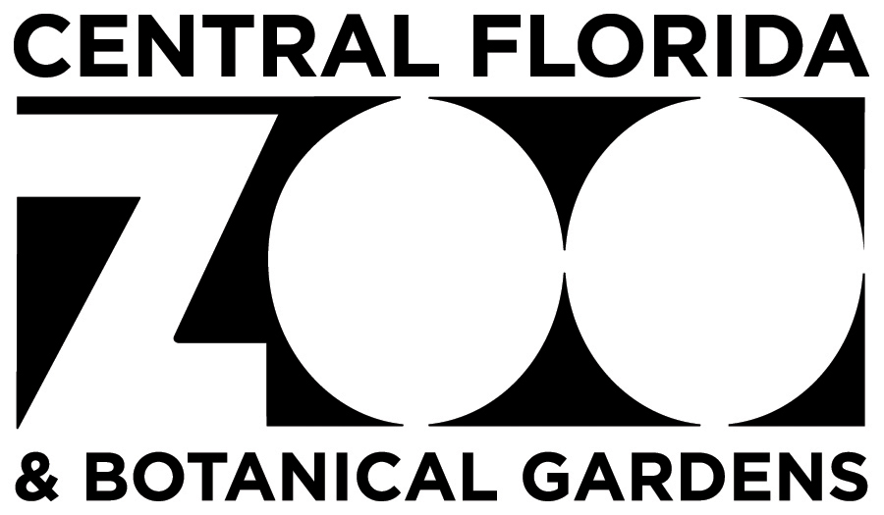

**Job Description**

**Job Title:** **Development Officer**

**Reports To:** **Chief Development Officer**

FLSA Status: Exempt – Full Time

**SUMMARY:**

Reporting to the Chief Development Officer, the Development Officer will be responsible for identifying, qualifying, recruiting, engaging, and managing a portfolio with an emphasis on ensuring donors are discovered, engaged, retained, and involved in the Zoo’s fundraising programs (including but not limited to individual, corporate, and foundational giving; annual and capital campaigns; special events, etc.). The Development Officer will focus on all aspects of relationship/moves management including growing the donor’s knowledge of the organization, involvement with the organization, financial support and more. This includes but is not limited to personal meetings, tours, donor engagement events, special events, and other methods of cultivation. This person will occasionally serve as the Zoo’s representative at community events and with community organizations as needed. They will be responsible for helping the Development team obtain budgeted annual fundraising goals and will collaborate with the other members of the Development team. The Development Officer will work closely with the C.D.O. to build upon the Zoo's culture of philanthropy, both internally and among its supporters.

**ESSENTIAL DUTIES AND RESPONSIBILITIES:**

Manage a portfolio of donor prospects and lead efforts to develop and implement cultivation, solicitation, and stewardship plans for each, ensuring plans are complete, strategic, sustainable, and effective. Direct activities include:

* Support the Chief Development Officer in all fundraising efforts, including capital campaigns, annual giving, major gifts, planned giving, soliciting gifts, corporate sponsorship, etc.
* Focus efforts around cultivation, solicitation and stewardship events, visits, calls, letters, etc.
* Solicit prospects based on their experiences with, and interest in, the Zoo, and their giving capacity
* Educate and engage key members of Zoo staff to ensure successful and impactful participation in donor activities
* Work closely with CDO to promote/sell a year-round corporate sponsorship program
* Achieve activity (calls, meetings, solicitations per month) and financial goals created on an annual basis
* Help to develop strategic funding requests based on immediate needs and long-term funding goals of the Zoo
* Help to identify new prospects from a variety of sources, including donor lists, prospect screening information, local publications, wealth finder systems, and conversations with existing donors and contacts
* Help to identify current annual donors and pass holders who can make major gifts; design and implement appropriate strategies
* Conduct effective and engaging in-person presentations to high-level audiences in support of Zoo projects and programs. Serve as the Zoo’s representative at community events/networking opportunities as needed
* Develop/prepare materials – including letters, proposals, meeting prep, stewardship reports, etc. – to support development strategies and programs
* Manage and update contact information, plans, and actions in Virtuous CRM using identified protocol, complete timely and accurate call, and progress reports
* Work closely and collaboratively with representatives from across the Zoo to ensure timely and effective marketing for development events.

QUALIFICATIONS:

The requirements listed below are representative of the knowledge, skill, and ability required. Reasonable accommodations may be made to enable individuals with disabilities to perform the essential functions.

* Management skills and experience are required, including but not limited to short and long-term planning, evaluation, strong oral and written communication skills, some budgeting/financial management, and knowledge of nonprofit fundraising regulations and best practices.
* Knowledge of cultivation, solicitation, stewardship strategies, and techniques in fundraising and annual funds.
* Versed in grant and proposal writing at appropriate levels for varied proposal development, knowledge of methods, practices, and procedures for obtaining information.
* History of cultivating and securing major gifts.
* Knowledge of the philanthropic community in Central Florida.
* Ability to work independently and as a team member.
* Ability to always maintain a professional and respectful demeanor, including during stressful situations.
* Ability to build and maintain excellent relationships with a diverse culture, both with employees and business contacts.
* Self-motivated and disciplined to regularly set and achieve work goals.
* Commitment to the mission of the Central Florida Zoo & Botanical Gardens.
* A Bachelor's degree with 2-4 years of demonstrated successful fundraising experience, preferably in zoos or a non-profit setting (or a comparably complex organization).
* Must provide a negative drug test result.

LANGUAGE ABILITY:

* Ability to respond to common inquiries, requests, or complaints from guests and staff in a kind and courteous manner.
* Must be able to prepare clear and concise reports.
* Multi-lingual is a plus.

REASONING ABILITY:

* Ability to define problems, collect data, establish facts, and draw valid conclusions.

CERTIFICATES, LICENSES, REGISTRATIONS:

* Valid Florida State driver license.
* Certified Fund-Raising Executive (CFRE) preferred.

PHYSICAL DEMANDS:

* In compliance with the Americans with Disabilities Act, the following have been identified as physical requirements of the job:
* The employee must frequently lift or move up to 25 pounds, occasionally lift or move up to 50 pounds, stand for extended periods, and drive Zoo vehicles.
* This job's specific vision abilities include close vision, distance vision, peripheral vision, depth perception, and the ability to adjust focus. While performing the duties of this job, the employee is regularly required to talk or listen.
* The employee is frequently required to use hands and fingers to handle, reach, or feel and manipulate objects or controls. The employee is regularly required to sit, walk distances, climb, balance, stoop, bend, kneel, and crouch.

Reasonable accommodations may be made to enable individuals with disabilities to perform the essential functions.

WORK ENVIRONMENT:

* A large percentage of the job functions are performed in an office atmosphere. Exposure to Florida weather environments should be considered.

Central Florida Zoo & Botanical Gardens reserves the right to revise or change job duties and responsibilities as the need arises. This job description pertains to an "at-will" position with the Central Florida Zoo & Botanical Gardens and in no way constitutes a written or implied contract of employment.

Employee (Print name) __________________________________________________________

Employee's signature ____________________________________________________________

President/CEO _________________________________________________________________

Date _________________________________________________________________________

The Central Florida Zoological Society is an equal opportunity employer and makes decisions related to compensation and all terms, conditions, or privileges of employment based on merit. Company policy prohibits unlawful discrimination based on race, color, creed, sex (including pregnancy), gender orientation, religion, marital status, age, national origin, or ancestry, physical or mental disability, medical condition, genetic characteristic, military status, or any other consideration made unlawful by federal, state, or local laws. All such discrimination is unlawful and prohibited by the CFZS.