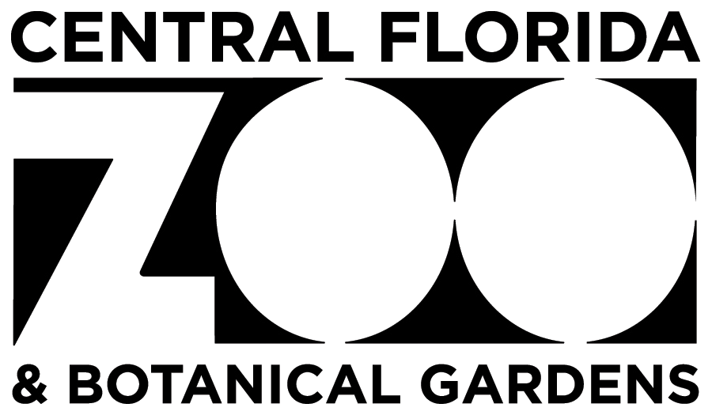

Job Description

Job Title: Safety and Security Officer
Job Number: 1137
Reports To: Public Safety Manager
FLSA Status: Part-time, non-exempt
Pay Range:

SUMMARY:
The Safety and Security Officer reports directly to the Safety and Security Manager. This position is responsible for security, including but not limited to the safety and protection of the animals and property of the Central Florida Zoo & Botanical Gardens against fire, flooding, theft, vandalism, and illegal entry during non-operating hours.

ESSENTIAL DUTIES AND RESPONSIBILITIES:
The employee in this position must be able to perform all the essential job duties listed below; however, this list is not intended to be inclusive of the specific tasks that an employee in this position may be expected to perform.
- Be an ambassador for the Zoo at all times.
- Respond to emergency situations as needed.
- Have a working knowledge of radio procedures to ensure safety protocol for guests and employees.
- Check and secure all access areas on Zoo property and perimeter areas. Check buildings for proper temperature, lights left on, or other irregularities.
- Regularly patrol interior Zoo grounds and outer perimeter areas.
- Document ingress and egress by all individuals after hours.
- Monitor animal exhibits, holding areas, and specific animals as directed by animal care staff. (Physical contact with the specimen collection is not permitted.)
- Note and document all conditions in which guest and staff safety may be compromised, such as unlevel walkways, low-hanging branches over walkways, and boardwalk planks and railings in need of repair.
- Monitor for and report irregularities such as fire hazards, leaking pipes, and security doors left unlocked.
- Call the police or fire department and designated Zoo officials in case of emergency.
- Record data such as property damage, unusual occurrences, locks left unlocked, and malfunctioning of equipment.
- Provide additional assistance prior to Zoo events to ensure cleanliness and guest safety as requested.
- Act as security personnel at specific Zoo events.
- Adhere to all Central Florida Zoological Society, Inc. policies and procedures.
- Perform other duties as assigned.

The duties listed above are intended only as an illustration of the various types of work that may be performed. The omission of specific statements of duties does not exclude them from the position if the work is similar, related, or a logical assignment to the position.
Qualifications:
The requirements listed below are representative of the knowledge, skill, and/or ability required. Reasonable accommodations may be made to enable individuals with disabilities to perform the essential functions.
- Must be a minimum of 18 years old.
- Must provide a negative drug test result.
- Must pass a pre-employment background check.
- Must be able to give and follow verbal and written directions and instructions.
- Must be able to multi-task and use software programs.
- Must be able to work independently and as part of a team.
- Must wear/use protective equipment that is appropriate for daily tasks.
- Must be able to distinguish and document safety hazards and submit reports accordingly.
- Must be able to maintain effective working relationships with Zoo employees, vendors, and the public.
- Must have the ability to work flexible hours, including weekdays, weekends, holidays, and evenings.

EDUCATION AND EXPERIENCE:
- This position requires a minimum of a high school diploma or equivalent.
- Previous experience working in a security-related field is preferred.
- Basic life support, first aid, and CPR/AED certifications are preferred.

LANGUAGE ABILITY:
- Must be able to respond to inquiries, requests, or complaints from guests, staff, vendors, or the public in a kind and courteous manner.
- Must be able to effectively communicate with guests, staff, and emergency responders.
- Must be able to read and understand directions, both verbally and in writing.
- Multilingual is a plus.

REASONING ABILITY:
- Must be able to define problems, collect data, establish facts, and draw valid conclusions.
- Must be able to think logically and solve problems with little or no guidance.

CERTIFICATES, LICENSES, REGISTRATIONS:
- Must possess a valid Florida State Driver’s License.
- Onsite first aid responder and CPR/AED trained within six (6) months of hire.

PHYSICAL DEMANDS:
In compliance with the Americans with Disabilities Act, the following have been identified as physical requirements of the job:
- The employee must frequently lift and/or move up to 50 pounds and occasionally lift and/or move up to 75 pounds.
- The employee must be able to drive Zoo vehicles.
- Specific vision abilities required by this job include close vision, distance vision, peripheral vision, depth perception, and ability to adjust focus.
- While performing the duties of this job, the employee is regularly required to talk and hear.
- The employee is frequently required to use hands and fingers to reach, feel, and manipulate objects or controls.
- The employee is frequently required to sit, stand, walk distances, climb, balance, stoop, bend, kneel, and crouch.
- Some job functions of this position may be performed in confined areas.

Reasonable accommodations may be made to enable individuals with disabilities to perform the essential functions.

WORK ENVIRONMENT:
The majority of duties are performed outdoors in various weather conditions, ranging from rain, wind, cool to cold weather, and extreme heat and humidity. It is possible the employee will be exposed to dust, allergens, or harsh chemicals that may present a health hazard if not handled properly. The noise level in the work environment is usually moderate.

The Central Florida Zoological Society, Inc. (CFZS) reserves the right to revise or change job duties and responsibilities as the need arises. This job description pertains to an “at will” position with the CFZS and in no way constitutes a written or implied contract of employment. The CFZS is an equal opportunity employer and welcomes a diverse pool of candidates to apply for this position.

The Central Florida Zoological Society, Inc. (CFZS) is an equal opportunity employer and makes decisions related to compensation and all terms, conditions, or privileges of employment based on merit. Company policy prohibits unlawful discrimination based on race, color, creed, sex (including pregnancy), gender orientation, religion, marital status, age, national origin or ancestry, physical or mental disability, medical condition, genetic characteristic, military status, or any other consideration made unlawful by federal, state, or local laws. All such discrimination is unlawful and prohibited by the CFZS.

